|  |  |  |  |  |  |  |  |  |  |
| --- | --- | --- | --- | --- | --- | --- | --- | --- | --- |
| **SCHOOL OF COMPUTER SCIENCE AND ARTIFICIAL INTELLIGENCE** | | | | | **DEPARTMENT OF COMPUTER SCIENCE ENGINEERING** | | | | |
| **ProgramName:**B. Tech | | | | **Assignment Type: Lab** | | | **AcademicYear:**2025-2026 | | |
| **CourseCoordinatorName** | | | | Venkataramana Veeramsetty | | | | | |
| **Instructor(s)Name** | | | | |  | | --- | | Dr. V. Venkataramana (Co-ordinator) | | Dr. T. Sampath Kumar | | Dr. Pramoda Patro | | Dr. Brij Kishor Tiwari | | Dr.J.Ravichander | | Dr. Mohammand Ali Shaik | | Dr. Anirodh Kumar | | Mr. S.Naresh Kumar | | Dr. RAJESH VELPULA | | Mr. Kundhan Kumar | | Ms. Ch.Rajitha | | Mr. M Prakash | | Mr. B.Raju | | Intern 1 (Dharma teja) | | Intern 2 (Sai Prasad) | | Intern 3 (Sowmya) | | NS_2 ( Mounika) | | | | | | |
| **CourseCode** | | | 24CS002PC215 | **CourseTitle** | | AI Assisted Coding | | | |
| **Year/Sem** | | | II/I | **Regulation** | | R24 | | | |
| **Date and Day**  **of Assignment** | | | Week3 - Thursday | **Time(s)** | |  | | | |
| **Duration** | | | 2 Hours | **Applicableto**  **Batches** | |  | | | |
| **AssignmentNumber:5.4**(Present assignment number)/**24**(Total number of assignments) | | | | | | | | | |
|  | | | | | | | | | |
|  | **Q.No.** | **Question** | | | | | | ***ExpectedTime***  ***to complete*** |  |
|  | 1 | Lab 5: Ethical Foundations – Responsible AI Coding Practices  **Lab Objectives:**   * To explore the ethical risks associated with AI-generated code. * To recognize issues related to security, bias, transparency, and copyright. * To reflect on the responsibilities of developers when using AI tools in software development. * To promote awareness of best practices for responsible and ethical AI coding.   **Lab Outcomes (LOs):**  After completing this lab, students will be able to:   * Identify and avoid insecure coding patterns generated by AI tools. * Detect and analyze potential bias or discriminatory logic in AI-generated outputs. * Evaluate originality and licensing concerns in reused AI-generated code. * Understand the importance of explainability and transparency in AI-assisted programming. * Reflect on accountability and the human role in ethical AI coding practices..   **Task Description #1:**  **•** Prompt GitHub Copilot to generate a Python script that collects user data (e.g., name, age, email). Then, ask Copilot to add comments on how to anonymize or protect this data.  **Expected Output #1:**  **•** A script with inline Copilot-suggested code and comments explaining how to safeguard or anonymize user information (e.g., hashing emails, not storing data unencrypted).  **Task Description #2:**  **•** Ask Copilot to generate a Python function for sentiment analysis. Then prompt Copilot to identify and handle potential biases in the data.  **Expected Output #2:**  **•** Copilot-generated code with additions or comments addressing bias mitigation strategies (e.g., balancing dataset, removing offensive terms).  **Task Description #3:**  **•** Use Copilot to write a Python program that recommends products based on user history. Ask it to follow ethical guidelines like transparency and fairness.  **Expected Output #3:**  **•** Copilot suggestions that include explanations, fairness checks (e.g., avoiding favoritism), and user feedback options in the code.  **Task Description #4:**  • Prompt Copilot to generate logging functionality in a Python web application. Then, ask it to ensure the logs do not record sensitive information.  **Expected Output #4:**  • Logging code that avoids saving personal identifiers (e.g., passwords, emails), and includes comments about ethical logging practices.  **Task Description #5:**  **•** Ask Copilot to generate a machine learning model. Then, prompt it to add documentation on how to use the model responsibly (e.g., explainability, accuracy limits).  **Expected Output #5:**  **•** Copilot-generated model code with a README or inline documentation suggesting responsible usage, limitations, and fairness considerations.  **Note: Report should be submitted a word document for all tasks in a single document with prompts, comments & code explanation, and output and if required, screenshots**  **Evaluation Criteria:**   | **Criteria** | **Max Marks** | | --- | --- | | How to anonymize or protect this data | 0.5 | | Identify and handle potential biases in the data. | 0.5 | | Follow ethical guidelines like transparency and fairness. | 0.5 | | logs do not record sensitive information. | 0.5 | | How to use the model responsibly | 0.5 | | **Total** | **2.5 Marks** | | | | | | | Week3 - Thursday |  |

**Task Description #1:**

**•** Prompt GitHub Copilot to generate a Python script that collects user data (e.g., name, age, email). Then, ask Copilot to add comments on how to anonymize or protect this data.

**Expected Output #1:**

**•** A script with inline Copilot-suggested code and comments explaining how to safeguard or anonymize user information (e.g., hashing emails, not storing data unencrypted).

Task 1_1:

Prompt:Generate a python function that Collects student details such as (name,age,Email) from the console and adds that data in a new text file

Screenshot:

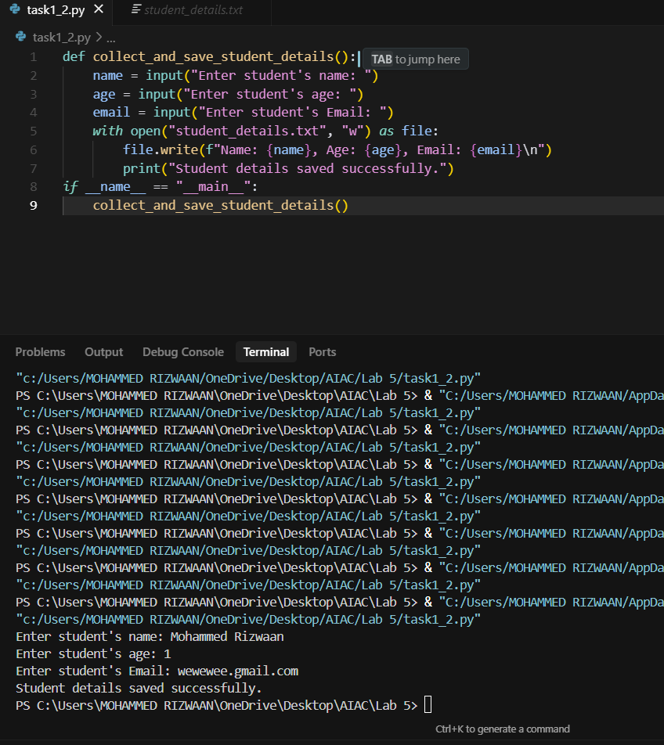

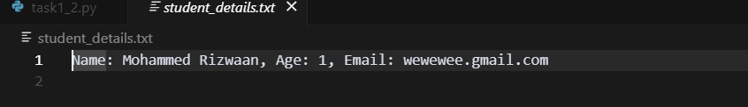

Task 1_2:

Prompt: Generate a python function that Collects student details such as (name,age,Email) from the console and adds that data in a new text file but now encrypt the data to ensure security.

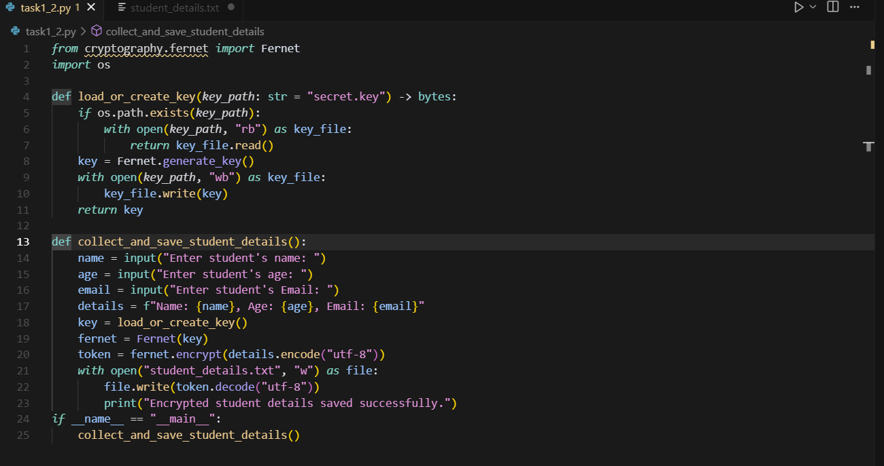

Output:



**Task Description #2:**

**•** Ask Copilot to generate a Python function for sentiment analysis. Then prompt Copilot to identify and handle potential biases in the data.

**Expected Output #2:**

**•** Copilot-generated code with additions or comments addressing bias mitigation strategies (e.g., balancing dataset, removing offensive terms).

Prompt:

Generate a python function that reads a review from the console and give output wheather the given input is positive or negative review.

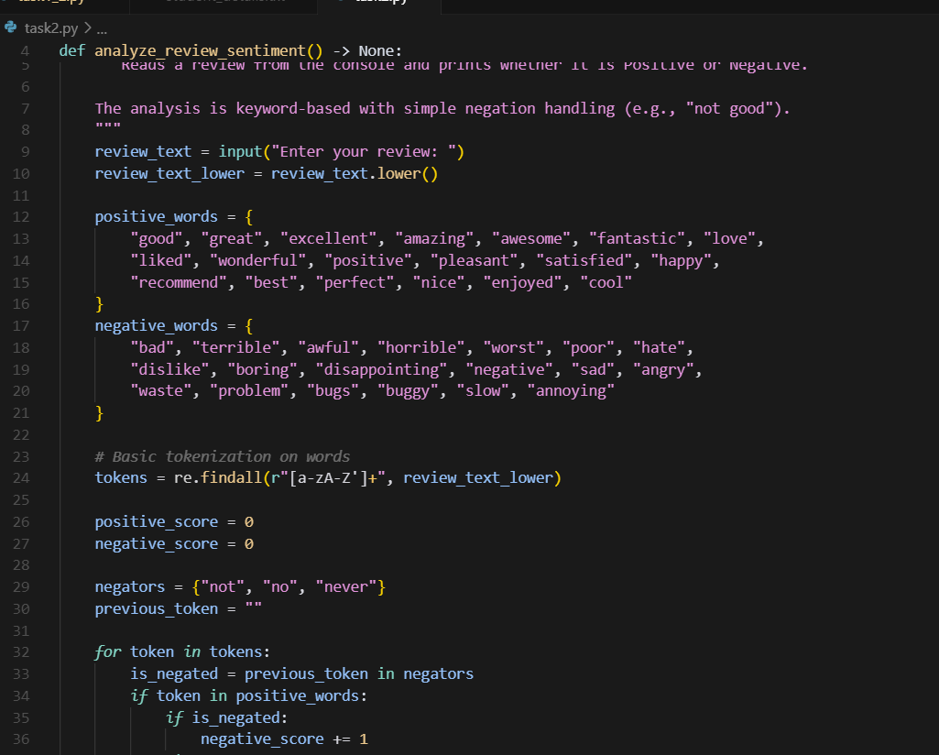

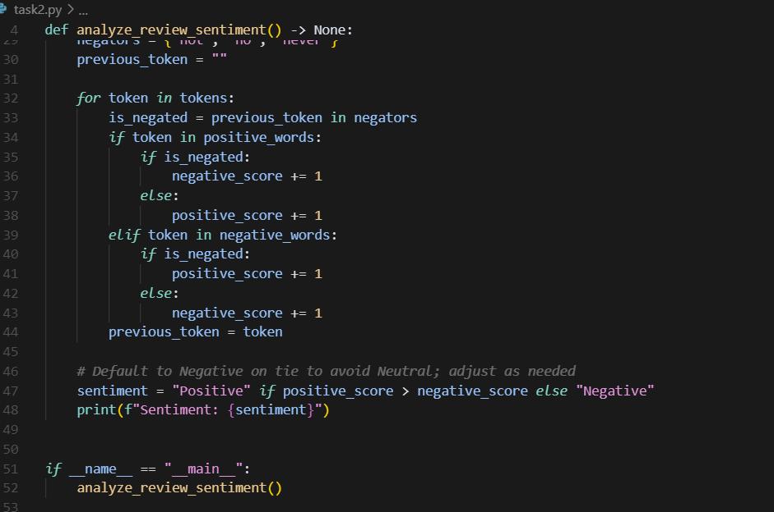

Output: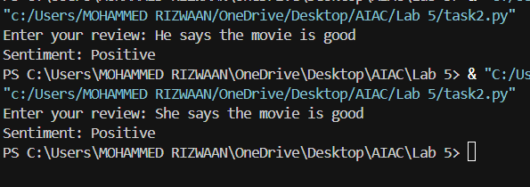

**Task Description #3:**

**•** Use Copilot to write a Python program that recommends products based on user history. Ask it to follow ethical guidelines like transparency and fairness.

**Expected Output #3:**

**•** Copilot suggestions that include explanations, fairness checks (e.g., avoiding favoritism), and user feedback options in the code.

Prompt:

Generate a python function that recommends products based on the user history that includes explanations and user feedback options  
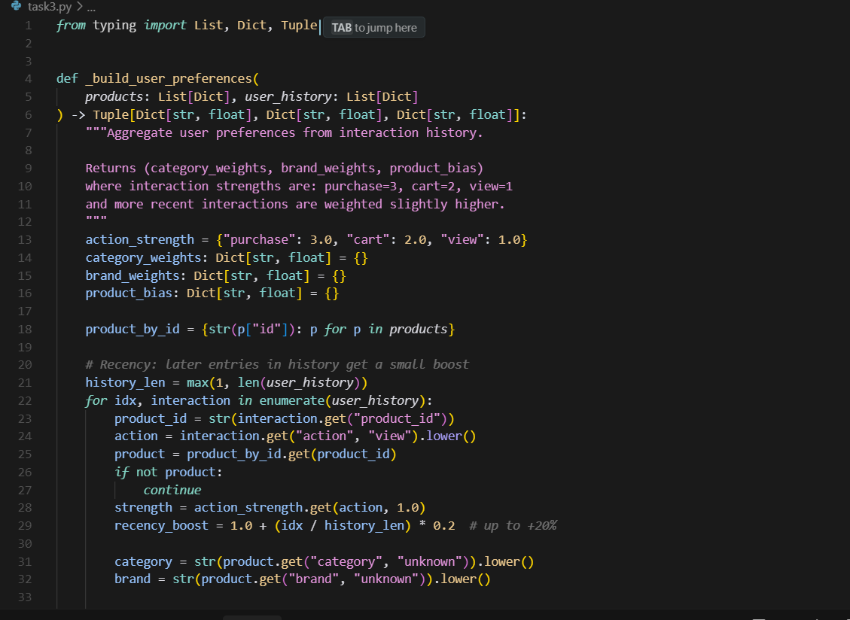

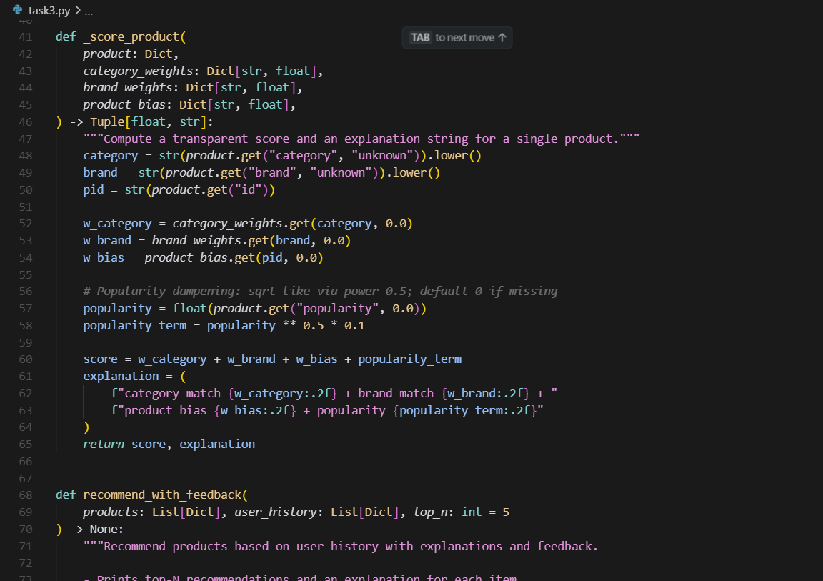

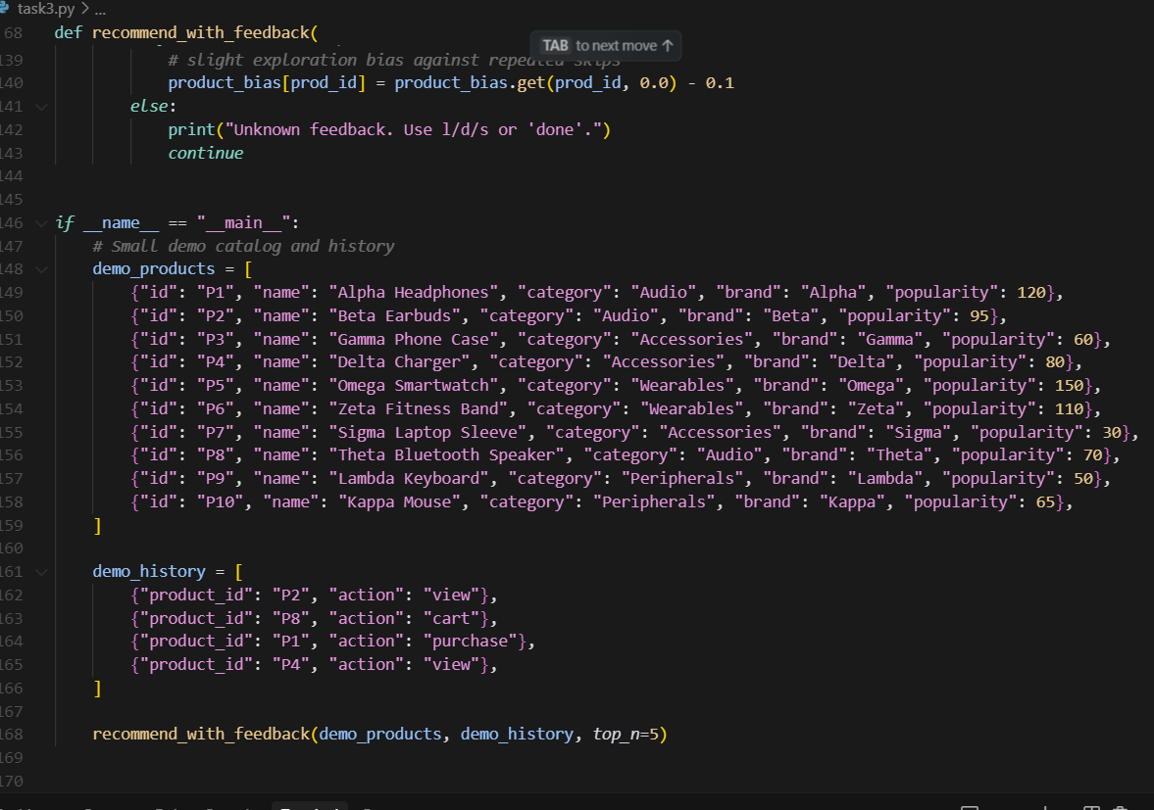

Output:

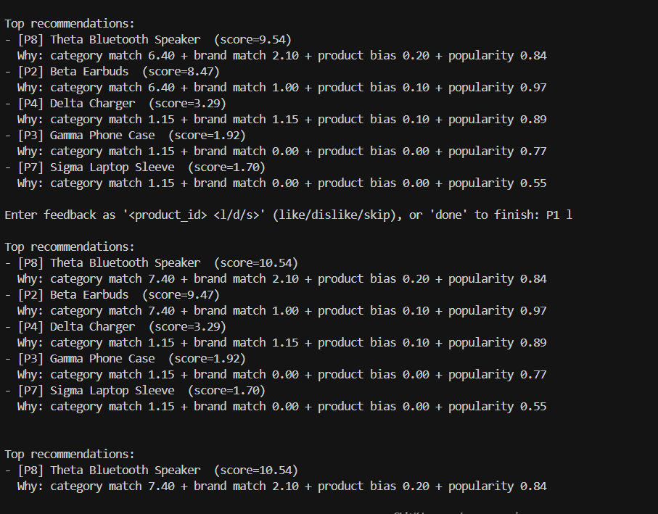

**Task Description #4:**

• Prompt Copilot to generate logging functionality in a Python web application. Then, ask it to ensure the logs do not record sensitive information.

**Expected Output #4:**

• Logging code that avoids saving personal identifiers (e.g., passwords, emails), and includes comments about ethical logging practices.

2